BrowserMonkey

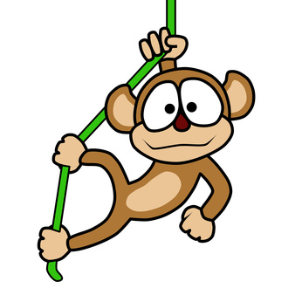

Requirements Specification

v 1.0

Software House One

Version History

Document name: se-proj1/SVNRepository/Analysis Team/baselined/Requirements Specification 1.0.doc
Document version: 1.0
Document author: Sara Aspery 2009/03/12
Document author: Ioanna Kyprianou 2009/03/12
Document author: Eirini Schizas 2009/03/12
Document author: Mehmet Guven 2009/02/10
Document author: Elpida Kyriakou 2009/03/12
Document author: Sohani Amiruzzaman 2009/03/12
Document auditor: Ioanna Kyprianou 2009/03/12
Document auditor: Daniel Cooper 2009/03/12
Document auditor: Paul Calcraft 2009/03/12
Document auditor: Sara Aspery 2009/03/12
Last modification date: 2009/03/12

Table of Contents

Introduction 6
1 Requirement 1 – Basic Renderer 7
1.1 Overview 7
1.2 Whitespace 8
1.3 Starting the program 9
1.4 Opening an HTML document 10
1.4.1 Opening a document from the command line 10
1.4.2 Opening a document from the address bar 11
1.4.3 Opening a document via the browse dialogue 11
1.5 Graphical User Interface 12
1.5.1 Window title 12
1.5.2 Scrolling 13
1.5.3 Altering window size and position 13
1.5.4 Rendered Elements 13
2 Requirement 2 - Logging 14
2.1 Activating logging 14
2.2 Log file name 14
2.3 Log file size 14
2.4 Log file entry format 14
2.5 Log file error descriptions 15
3 Requirement 3 – Conformance 16
3.1 Overview 16
3.2 Invalid tag format 17
3.3 Empty tags 17
3.4 Unrecognised tags 18
3.5 Recognised non-implemented tags 18
3.6 General structure tags 19
3.7 Recognised supported tags 20
3.8 Font tag attributes 25
3.9 Nesting and Order 28
3.9.1 Headings 28
3.9.2 List Items 28
3.9.3 Definition list terms and definitions 28
3.9.4 Table rows and data cells 29
3.10 Content Model 30
4 Requirement 4 – Tags 31
4.1 Blank lines 31
4.2 Heading 32
4.3 Paragraph 35
4.4 Unordered List 37
4.4.1 Unordered List Tags 37
4.4.2 List Item Element Tags 38
4.5 Ordered List 42
4.5.1 Ordered List Tags 42
4.5.2 List Element Tags 43
4.6 Definition List 47
4.6.1 Definition List Tags 47
4.6.2 Definition List Term Tags 48
4.6.3 Definition List Description Tags 49
4.7 Blockquote 53
4.8 Centered Text 55
4.9 Pre-formatted Text 57
4.10 Horizontal Rule 59
4.11 Italics 60
4.12 Bold 61
4.13 Teletype 62
4.14 Underline 63
4.15 Font 64
5 Requirement 5 – Tables 66
5.1 Table Tags 66
5.2 Table Row Tags 67
5.3 Table Data Tags 68
6 Requirement 6 – Links 72
7 Requirement 7 – Search 73
8 Requirement 8 – Zoom 74
9 Analysis Model 75
9.1 Stakeholder and Actor Descriptions 75
9.1.1 Low-Tech Operator: 75
9.1.2 High-Tech Operator: 75
9.1.3 Html writer: 75
9.1.4 Developers: 76
9.2 Use Cases 77
9.2.1 Basic and Alternatives course of events: 79
9.3 CRC cards 81
9.3.1 GUI 81
9.3.2 Parser 81
9.3.3 Document 81
9.3.4 DocumentPanel 82
9.3.5 Tokeniser 82
9.3.6 HotLinker 83
9.3.7 Searcher 83
9.3.8 DocumentPresenter 84
9.3.9 DocumentNode 84
9.3.10 TextProvider 85
9.3.11 RenderNode 85
9.4 Collaborating classes identification 86
9.4.1 View manual 86
9.4.2 Follow link 87
9.4.3 Search page 88
9.4.4 Zoom page 88
9.5 Initial class model 89
Appendix A – HTML 4.01 Transitional Elements 90
Appendix B – ASCII Characters 93
Appendix C – Supported HTML Standard Character Entities 95
Appendix D – Supported Font Colour Names 96
Appendix E – GUI Prototype 97
Appendix F – References 98
Appendix G – List of Abbreviations 99

Introduction
This document describes the requirements specification for the Software Engineering course project by Software House One. The goal of the project, “BrowserMonkey” is to develop a new application browser for documents written in Hypertext Mark-up Language (HTML).

The browser is intended for use in agricultural machinery, for example a tractor dashboard, to display documents such as the machinery user manual. It will read and display a document written in HTML, including extensions added by Netscape, although not all HTML and Netscape extensions functionality will be implemented. It was also agreed to provide some features in addition to those specified in the Customer Requirements document¹. This document describes the analysis and breakdown of the full customer requirements as understood from the Customer Requirements document¹ and the customer meeting in week five. It shall be used as a basis for the acceptance criteria and high-level design specification.

Requirement 1 – Basic Renderer
A basic text renderer, including a simple parser with internet files capability, renderer and Graphical User Interface (GUI).

Overview
The document character set will be the ASCII character set listed in Appendix B.
The list of HTML standard character entities (such as &amp;) which BrowserMonkey supports is given in Appendix C. Supported character entities can be referenced by their names, or by their decimal / hexadecimal equivalents, for example:

this is a pound &pound; so is this &#163; so is this &#xA3;

will render as:

this is a pound £ so is this £ so is this £

Entity names are case sensitive, and unrecognised entities will be rendered as normal text, for example:

some &quot;text &Quot; &amp; and this is some more &foo; text

will render as:

some "text &Quot; & and this is some more &foo; text

Hexadecimal entity references are not case sensitive, so &#xa3; &#xA3; &#Xa3; and &#XA3; will all render the same character entity.

Whitespace
Spaces inside tag brackets, e.g. < b > will be ignored. Spaces within text will be rendered but multiple space characters will render as only 1 space character, for example:

some <b> text and some more text

will render as:

some text and some more text

Whitespace will be ignored inside and outside tag brackets. A list of the ASCII characters considered to be whitespace is included in appendix B.

Carriage return (CR), linefeed (LF) and carriage return + linefeed (CRLF) will each be treated as a single space character. Multiple instances will render as a single space.

Spaces and whitespace characters are handled differently when enclosed by <pre> </pre> tags. For further explanation see the preformatted text description in section 5.9.

Starting the program
The program will be started from the command line:

java BrowserMonkey

If no filename or address is passed as an argument, BrowserMonkey will attempt to open “index.html” from the current local directory, and if “index.html” does not exist it will attempt to open “index.htm”. If “index.htm” also does not exist, BrowserMonkey will start with no document open, and will display an error page instead.

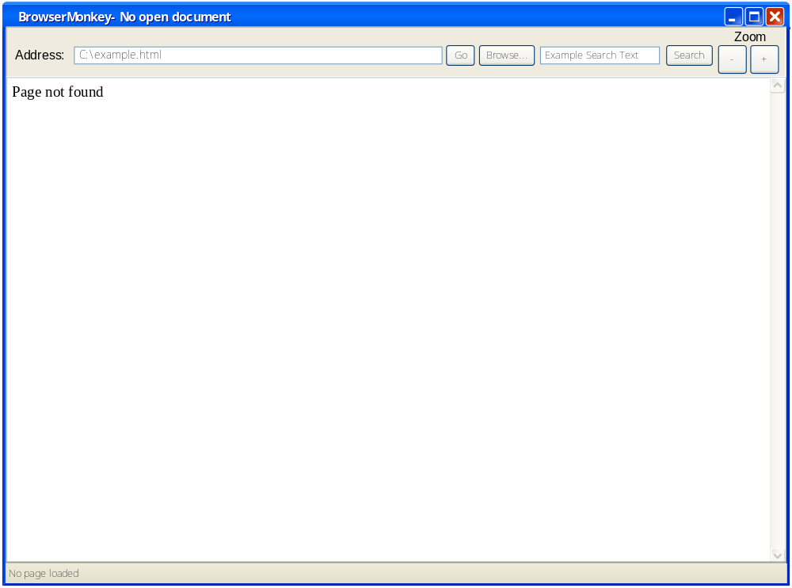

A default index.html file will be supplied with the BrowserMonkey source code.

Opening an HTML document
BrowserMonkey will open documents which are held locally, or accessed via the internet. Any file extension is permitted, although all files will be rendered as HTML documents, regardless of extension.

Opening a document from the command line
A document can be opened by specifying its path, filename and extension as an argument when starting the program from the command line. For example to start BrowserMonkey with a locally held file:

java BrowserMonkey C:\DataFiles\Manuals\thresher.html

To start BrowserMonkey with a file accessed via the internet:

java BrowserMonkey www.customersite.com/thresher.html

If the file is not found, an error page will be displayed. If the file extension is omitted, BrowserMonkey will assume that only a file path has been entered, and will attempt to open “index.html” from the specified path, for example:

java BrowserMonkey C:\DataFiles\Manuals

will cause the program to try opening C:\DataFiles\Manuals\index.html. If “index.html” does not exist it will attempt to open “index.htm” from the same path. If “index.htm” also does not exist, BrowserMonkey will start with no document open, and will display an error page instead.

For an internet file path, the IP address may be specified instead of the domain name, for example:

java BrowserMonkey 192.168.10.0/thresher.html

Opening a document from the address bar
When the browser is already running, a file can be opened by typing its path, filename and extension directly into the address bar and clicking the “Go” button. If the file is to be accessed via the internet, the address must be prefixed with “http://”.

As with opening a document from the command line, if the file is not found, an error page will be displayed. If the file extension is omitted, BrowserMonkey will assume that only a file path has been entered, and will attempt to open “index.html” and then “index.htm” from the specified path. If the file cannot be found, the error page will be displayed.

Also, as with opening a document from the command line, the IP address may be specified instead of the domain name.

The path, filename and extension (including “http://” if entered) are limited to a maximum of 255 characters.

Opening a document via the browse dialogue
Alternatively, the user can click the “Browse” button to open a dialogue box which allows the user to navigate to the desired locally held file.

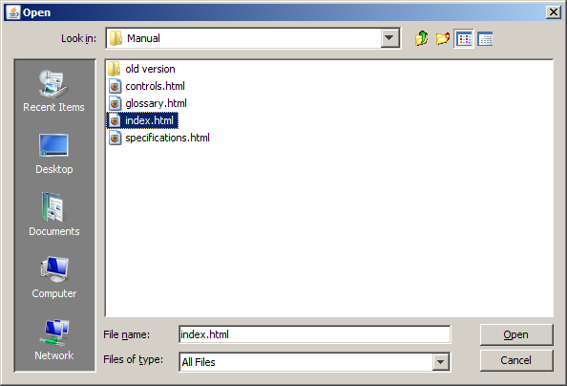

Graphical User Interface
A prototype of the BrowserMonkey GUI can be seen in Appendix E.

Window title
Text within the <title> </title> tags will be displayed as the window title. For example,

<title> Example HTML Page Title </title>

will be displayed as:

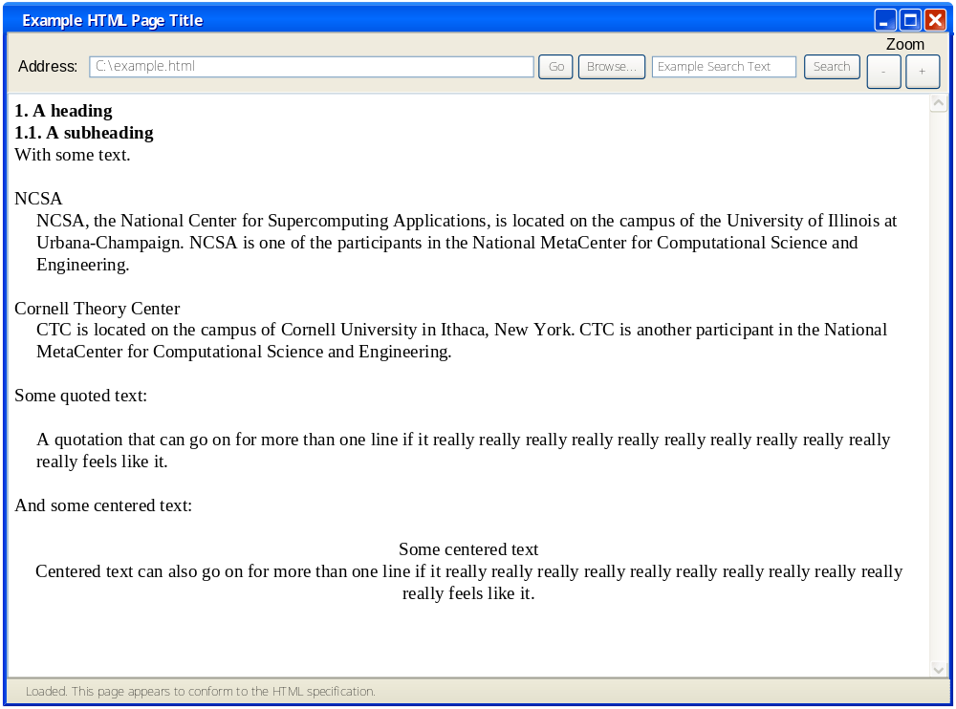

Whitespace in the text within the title tags will be ignored. Spaces within the text will be displayed including multiple space characters. HTML character entities will also be displayed. Any tags nested within the title tags will be displayed as part of the title text, for example:

<title> hello <b> w</b>orld how are &#quot; you</title>

will be displayed as:

hello <b> w</b>orld how are “ you

If the document does not contain a title element, the window title will be set to “BrowserMonkey – untitled document”. If no document is open, the window title will be set to “BrowserMonkey – No open document”.

Scrolling
A vertical scroll bar will provide the ability to view a page which is too long to fit within the visible window. If the page fits within the window, the vertical scroll bar will be greyed-out.
A horizontal scroll bar will only appear if the page contains non-breaking text which is wider than the window width.

Altering window size and position
The BrowserMonkey window can be moved and resized. Elements will resize inside the window as far as is practicable for them to do so. Tables, for example, can only be resized down so far, before they become unrecognisable as tables. If the window is resized such that it becomes narrower than any non-breaking text, the horizontal scroll bar will appear, and if the window is resized to become wider than any non-breaking text, the horizontal scroll bar will disappear.

Similarly, if resizing the window causes the page to become too long to fit in the window, the vertical scroll bar will be activated. If the page becomes shorter than the window, the vertical scroll bar will become greyed out.

Rendered Elements
BrowserMonkey will not render any content enclosed by the <head> </head> tag pair.
Text not within a heading or font tag pair will be rendered as 12pt Times New Roman. Rendered text will not be selectable by the user.

Requirement 2 - Logging
Ability to record the details of non-conformant HTML pages and broken links in a log file.

Activating logging
The logging feature will be activated by a command line switch when starting the program:

java BrowserMonkey -l

Log file name
The log file will be named “log.txt” and will reside in the current directory. If “log.txt” does not exist BrowserMonkey will create it. If it does exist, any new entries will be appended to the existing ones.

Log file size
To avoid problems caused by an expanding log file in a device with possibly very limited filespace, BrowserMonkey will not activate logging if the log file has already reached or exceeded an arbitrary maximum size. If the log file approaches the maximum size whilst the program is running, BrowserMonkey will simply deactivate the logging.

The maximum size will be set to 45K which will allow for approximately 658 messages (assuming an average message size of 70 characters).

Log file entry format
Log file entries will be 1 entry per line in the format: date time file linenumber error

31/12/2009 23:58 C:\Manuals\thresher.html Expected ‘>’ found ‘#’

date dd/mm/yyyy e.g. 31/12/2009
time hh:mm e.g. 23:58
file path/name.extn e.g. C:\Manuals\thresher.html
error e.g. Expected ‘>’ found ‘#’
linenumber on line n e.g. on line 932

If the log file is to be viewed using a browser rather than a text editor, its entire contents should first be enclosed in a <pre> </pre> tag pair to allow symbols such as < to display correctly. It is anticipated that this action would be carried out by the HTML writers where necessary.

Log file error descriptions
Only the first conformance error found for a page will be logged.

Conformance Errors
Log file message | Examples | Possible Causes
Unexpected char symbol on line n. | Unexpected < symbol on line 132. | Invalid tag format  Missing close tag bracket  Use of > rather than &gt;
Unrecognised tag tag on line n. | Unrecognised tag <zebra> on line 132. | Unrecognised tag
Expected tag on line n  Expected char on line n | Expected <head> on line 132  Expected “ on line 132 | Html, head or body open tag, close tag or tag pair missing.  Html, head or body tags out of sequence.  Color attribute not enclosed in quotes.
Multiple tag tag on line n | Multiple <html> tag on line 132 | Html, head or body tag occur more than once
<title> not in <head> | <title> not in <head> | Title tag not within <head> tag pair
Expected endtag for opentag on line n | Expected </h1> for <h1> on line 132 | Closing tag missing
Unexpected end tag endtag on line n. | Unexpected end tag </p> on line 132 | Surplus end tag
Unrecognised attribute attribute on line n | Unrecognised attribute ”greenwithyellowspots” on line 132 | Color attribute not recognised
Unexpected tag tag on line 132 | Unexpected tag <h3> on line 132 | Heading level skipped  List item tag outside list  List item nested in list item  Table data cell outside row or table  Table row outside table
Unexpected block element on line 132 | Unexpected block element on line 132 | Block-element contained within inline element
Duplicate attribute attribute on line 132. | Duplicate attribute ”color=”blue” on line 132. | Duplicate attribute in font element tag

Link Errors
Log file message | Examples | Possible Causes
file not found | www.customersite.com/thresher.html not found | Link references file which does not exist

Requirement 3 – Conformance

Overview
The browser is to indicate whether the HTML page conforms to the HTML specification. For the purposes of this project, the HTML specification is assumed to be the HTML 4.01 transitional specification. Successfully rendered conformant pages will display the status bar message:

“Loaded. Page appears to conform to the HTML specification”

Pages considered to be non-conformant will display the message

“Loaded. Page may not fully conform to the HTML specification”

and where possible will give details of the line number and non-conforming element.

BrowserMonkey can only give an indication of whether a page conforms to the HTML specification. A complete and fully accurate assessment of a page’s conformance would require the page to be compared against the HTML 4.01 transitional Document Type Definition (DTD), which is beyond the scope of this project.

In its notes on invalid documents² the Worldwide Web Consortium provides the following guidance:

This specification does not define how conforming user agents handle general error conditions, including how user agents behave when they encounter elements, attributes, attribute values, or entities not specified in this document.
However, to facilitate experimentation and interoperability between implementations of various versions of HTML, we recommend the following behavior:
- If a user agent encounters an element it does not recognize, it should try to render the element's content.
- If a user agent encounters an attribute it does not recognize, it should ignore the entire attribute specification (i.e., the attribute and its value).
- If a user agent encounters an attribute value it doesn't recognize, it should use the default attribute value.
- If it encounters an undeclared entity, the entity should be treated as character data.
We also recommend that user agents provide support for notifying the user of such errors.

This section describes the conformance checks which BrowserMonkey will perform, and the action it will take when it encounters non-conforming elements.

Invalid tag format
BrowserMonkey will assume that the symbols < and > always denote a tag opening or closing bracket. If the symbols are required to be rendered then the character entities &lt; and &gt; must be used.

Open tag bracket within tag brackets
Example | <<p>
Conformance Status Message | Page may not conform to HTML specification. Unexpected < symbol on line 132.
Log Message | Unexpected < symbol on line 132.
Rendering Action | Ignore extra < symbol and evaluate tag as if symbol not there

Close tag bracket within tag brackets
Example | <p>words></p>
Conformance Status Message | Page may not conform to HTML specification. Unexpected > symbol on line 132.
Log Message | Unexpected > symbol on line 132.
Rendering Action | Ignore extra > symbol and evaluate text as if symbol not there

Close tag bracket missing
Example | <p this is some text EOF
Conformance Status Message | Page may not conform to HTML specification. < symbol on line 132.
Log Message | Unexpected < symbol on line 132.
Rendering Action | Ignore < symbol and evaluate text as if symbol not there

Empty tags
The tags <> and </> will be ignored by BrowserMonkey.

Empty tag brackets
Example | <></>
Conformance Status Message | Loaded. Page appears to conform to the HTML specification
Log Message | None
Rendering Action | Ignore <></> tags and render any enclosed text as if empty tags not there.

Unrecognised tags
Recognised tags are those belonging to elements from the HTML 4.01 Transitional DTD and are listed in Appendix A. If BrowserMonkey encounters a tag which not in the list in Appendix A, it will assume that the tag is unrecognised and therefore does not conform. Tags are not case sensitive and can be in upper, lower or mixed case.

Unrecognised tag
Example | <zebra> some text </zebra>
Conformance Status Message | Page may not conform to HTML specification. Unrecognised tag <zebra> on line 132.
Log Message | Unrecognised tag <zebra> on line 132.
Rendering Action | Ignore tag and render enclosed text

Recognised non-implemented tags
Recognised tags are those belonging to elements from the HTML 4.01 Transitional DTD and are listed in Appendix A. Implemented tags are the subset of recognised tags for which BrowserMonkey provides functionality, such as the bold element <b>. BrowserMonkey will assume that recognised non-implemented tags are conformant, and it will not validate tag attributes or nesting. Also, it will not check for the presence or otherwise of any corresponding opening/closing tag of the pair.

Non-implemented tag
Example | <br> some text <strike> <tbody> more text
Conformance Status Message | Loaded. Page appears to conform to the HTML specification
Log Message | None
Rendering Action | Ignore non-implemented tags and render any enclosed text as if tags not there.

General structure tags
BrowserMonkey will recognise the HTML structure elements <html>, <head>, <body> and <title>. It will not validate attributes for these tags, but it will check for the presence and nesting order of the tags.

Html, head or body open tag, close tag or tag pair missing
Example | <html> </body> </html>
Conformance Status Message | Page does not conform to HTML specification. Expected <head> on line 132.
Log Message | Expected <head> on line 132.
Rendering Action | Render html as normal.

Html, head or body tag occur more than once
Example | <html><html><head></head><body></body></html>
Conformance Status Message | Page does not conform to HTML specification. Multiple <html> tag found on line 132.
Log Message | Multiple <html> tag on line 132.
Rendering Action | Render html as normal.

Html, head or body tags out of sequence
Example | <html><body></body><head></head></html>
Conformance Status Message | Page does not conform to HTML specification. Expected <head> on line 132.
Log Message | Expected <head> on line 132.
Rendering Action | Render html as normal.

Title tag not within <head> tag pair
Example | <html><head></head><body><title>Some Text</title></body></html>
Conformance Status Message | Page does not conform to HTML specification. <title> not in <head>
Log Message | <title> not in <head>
Rendering Action | Apply title text to window title anyway

Recognised supported tags
For the HTML elements that BrowserMonkey implements, it will not validate attributes, but it will check for the completeness of tag pairs, and the nesting rules of the tags.

Closing tag missing
Example | <b> some text <p> more text </p>
Conformance Status Message | Page does not conform to HTML specification. Expected </b> for <b> on line 132.
Log Message | Expected </b> for <b> on line 132
Rendering Action | Render as if </b> tag exists at very end of document.

Closing tag missing – paragraph element
Example | <p> some text <p> more text </p>
Conformance Status Message | Page does not conform to HTML specification. Expected </p> for <p> on line 132.
Log Message | Expected </p> for <p> on line 132
Rendering Action | Auto correct – i.e. render as if </p> tag inserted immediately before next <p>. If no next <p> then render as if </p> tag exists at very end of document.
Note that the auto-correction for the paragraph element will prevent paragraph tags being nested within each other.

Closing tag missing – heading element
Example | <h1> This is heading 1 text </h1>  <h2> This is heading 2 text  <h3> This is heading 3 text </h3>,  </h2>
Conformance Status Message | Page does not conform to HTML specification. Expected </h2> for <h2> on line 132.
Log Message | Expected </h2> for <h2> on line 132
Rendering Action | Auto correct – i.e. render as if </h2> tag inserted immediately before next <hn>. If no next <hn> then render as if </h2> tag exists at very end of document.
Note that the auto-correction for the heading element will prevent heading tags being nested within each other.

Closing tag missing – list item element
Example  line 132 →  line 133 →  line 139 → | <ul>  <li> 1st list 1st item  <li> 1st list 2nd item  <ol>  <li> 2nd list 1st item </li>  <li> 2nd list 2nd item </li>  </ol>  some text between elements  some more text here<li> 1st list 3rd item </li>  <li> 1st list 4th item </li>  </ul>
Conformance Status Message | Page does not conform to HTML specification. Expected </li> for <li> on line 132.
Log Message | Expected </li> for <li> on line 132
Rendering Action | Auto correct – i.e. render as if </li> tag inserted immediately before next <li> at the same nesting level. If no next <li> then render as if </li> tag exists immediately before its containing </ul> or </ol> tag. If no </ul> or </ol> tag then render as if </li> tag exists at very end of document.  In the above example, the page would be rendered as though the </li> tag for the “1st list 1st item” on line 132 was inserted immediately before the <li> tag on line 133, and as though the </li> tag for the “1st list 2nd item” on line 133 was inserted after the “some more text here” and immediately before the <li> tag on line 139.
Note that the auto-correction for the list item element will prevent list item tags being nested within each other.

Closing tag missing – definition list element
Example  line 132 →  line 133 →  line 139 → | <dl>  <dt> 1st list 1st term  <dd> 1st list 1st definition  <dl>  <dt> 2nd list 1st term</dt>  <dd> 2nd list 1st definition</dd>  </dl>  some text between elements  some more text here<dt> 1st list 3rd item </dt>  <dd> 1st list 4th item </dd>  </dl>
Conformance Status Message | Page does not conform to HTML specification. Expected </dt> for <dt> on line 132.
Log Message | Expected </dt> for <dt> on line 132
Rendering Action | Auto correct – i.e. render as if missing </dt> or </dd> tag inserted immediately before next <dt> or <dd> at the same nesting level. If no next <dt> or <dd> then render as if </dt> or </dd> tag exists immediately before its containing </dl> tag. If no </dll> tag then render as if </dt> or </dd> tag exists at very end of document.  In the above example, the page would be rendered as though the </dt> tag for the “1st list 1st term” on line 132 was inserted immediately before the <dd> tag on line 133, and as though the </dd> tag for the “1st list 1st definition” on line 133 was inserted after the “some more text here” and immediately before the <dt> tag on line 139.

Closing tag missing – table row element
Example  line 132 →  line 133 →  line 141 →  line 142 → | <table>  <tr> <td> row 1 column 1 </td> <td> row 1 column 2 </td>  <tr> <td> row 2 column 1 </td>  <td> row 2 column 2  <table>  <tr> <td> t2 r1 c1 </td> <td> t2 r1 c2 </td></tr>  <tr> <td> t2 r2 c1 </td> <td> t2 r2 c2 </td></tr>  </table>  </td> </tr>  <tr> <td> row 3 column 1 </td> <td> row 3 column 2 </td></tr>  <tr> <td> row 4 column 1 </td> <td> row 4 column 2 </td>  </table>
Conformance Status Message | Page does not conform to HTML specification. Expected </tr> for <tr> on line 132.
Log Message | Expected </tr> for <tr> on line 132
Rendering Action | Auto correct – i.e. render as if </tr> tag inserted immediately before next <tr> at the same nesting level. If no next <tr> then render as if </tr> tag exists immediately before its containing </table> tag. If no </table> tag then render as if </tr> tag exists at very end of document.  In the above example, the page would be rendered as though the </tr> tag for row 1 on line 132 was inserted immediately before the <tr> tag on line 133, and as though the </tr> tag for row 4 on line 141 was inserted immediately before the </table> tag on line 142.

Closing tag missing – table data cell element
Example  line 132 →  line 133 →  line 134 → | <table>  <tr> <td> row 1 column 1 <td> row 1 column 2 </td> <tr>  <tr> <td> row 2 column 1 </td> <td> row 2 column 2 </td></tr>  <tr> <td> row 3 column 1 </td> <td> row 3 column 2 </tr>  </table>
Conformance Status Message | Page does not conform to HTML specification. Expected </td> for <td> on line 132.
Log Message | Expected </td> for <td> on line 132
Rendering Action | Auto correct – i.e. render as if </td> tag inserted immediately before next <td> at the same nesting level. If no next <td> then render as if </td> tag exists immediately before its containing </tr> tag. If no </tr> tag then render as if </td> tag exists at very end of document.  In the above example, the page would be rendered as though the </td> tag for row 1 column 1 on line 132 was inserted immediately before the <td> tag on line 132, and as though the </td> tag for row 3 column 2 on line 134 was inserted immediately before the </tr> tag on line 134.

Surplus end tag
Example | <p></p></p> or <hr></hr>
Conform Message | Page does not conform to HTML specification. Unexpected end tag on line 132.
Log Message | Unexpected end tag </p> on line 132.
Rendering Action | Ignore surplus end tag

Tag with attribute
Example | <p thisattributedefinitelydoesnotexist = 8></p>
Conform Message | Loaded. Page appears to conform to the HTML specification
Log Message | None
Rendering Action | Ignore attribute

Font tag attributes
BrowserMonkey implements two attributes for the font element: face and color. Any other attributes will be ignored.

No font attribute specified
Example | <font>
Conform Message | Loaded. Page appears to conform to the HTML specification
Log Message | None
Rendering Action | Ignore font element

Unrecognised font attribute
Example | <font size = zebra>
Conform Message | Loaded. Page appears to conform to the HTML specification
Log Message | None
Rendering Action | Ignore font attribute

Unrecognised font attribute
Example | <font size = zebra color=”#000000”>
Conform Message | Loaded. Page appears to conform to the HTML specification
Log Message | None
Rendering Action | Ignore font size attribute and render font according to color attribute

Color attribute not enclosed in quotes
Example | <font color=green>
Conform Message | Page does not conform to HTML specification. Expected “ on line 132.
Log Message | Expected “ on line 132.
Rendering Action | Ignore color attribute and render font in default colour, ie. as if color attribute not present

Color attribute not recognised
Example | <font color=”greenwithyellowspots”>
Conform Message | Page does not conform to HTML specification. Unrecognised attribute ”greenwithyellowspots” on line 132.
Log Message | Unrecognised attribute ”greenwithyellowspots” on line 132.
Rendering Action | Ignore color attribute and render font in default colour

Color attribute not valid
Example | <font color=”#0000000000000000000000”>
Conform Message | Page does not conform to HTML specification. Unrecognised attribute ”#0000000000000000000000” on line 132.
Log Message | Unrecognised attribute ”#0000000000000000000000” on line 132.
Rendering Action | Ignore color attribute and render font in default colour

Color attribute empty
Example | <font color=””>
Conform Message | Page does not conform to HTML specification. Unrecognised attribute ”” on line 132.
Log Message | Unrecognised attribute ”” on line 132.
Rendering Action | Ignore color attribute and render font in default colour

Duplicate Color attribute
Example | <font color=”red” color=”blue”>
Conform Message | Page does not conform to HTML specification. Duplicate attribute ”color=”blue” on line 132.
Log Message | Duplicate attribute ”color=”blue” on line 132.
Rendering Action | Ignore 2nd color attribute and render font in 1st attribute colour

Face attribute not enclosed in quotes
Example | <font face=verdana>
Conform Message | Page does not conform to HTML specification. Expected “ on line 132.
Log Message | Expected “ on line 132.
Rendering Action | Ignore face attribute and render font in default Times New Roman

Face attribute not recognised
Example | <font face=”greenwithyellowspots, verdana”>
Conform Message | Loaded. Page appears to conform to the HTML specification
Log Message | None
Rendering Action | Render font in first recognised and available font face. If none available, render in default font Times New Roman.

Face attribute empty
Example | <font face=””>
Conform Message | Page does not conform to HTML specification. Unrecognised attribute ”” on line 132.
Log Message | Unrecognised attribute ”” on line 132.
Rendering Action | Ignore face attribute and render font in default Times New Roman

Duplicate face attribute
Example | <font face=”arial” face=”verdana”>
Conform Message | Page does not conform to HTML specification. Duplicate attribute “face=”verdana”” on line 132.
Log Message | Duplicate attribute ”face=”blue”” on line 132.
Rendering Action | Ignore 2nd face attribute and render font in 1st attribute face

Nesting and Order
BrowserMonkey will attempt to validate the order of some HTML elements.

Headings
Heading levels cannot be skipped.

Heading level skipped
Example | <h1> This is heading 1 text </h1>  <h3> This is heading 3 text </h3>
Conform Message | Page does not conform to HTML specification. Unexpected tag <h3> on line 132.
Log Message | Unexpected tag <h3> on line 132
Rendering Action | Ignore tag and render enclosed text

List Items
List Item elements must be enclosed by an unordered or ordered list element, and cannot be nested within other list item tags.

List item outside list
Example | <li> list item text </li>  <ul> <li> list item 1 text </li> </ul>
Conform Message | Page does not conform to HTML specification. Unexpected tag <li> on line 132.
Log Message | Unexpected tag <li> on line 132
Rendering Action | Ignore tag and render enclosed text

Definition list terms and definitions
Definition list term and definition elements must be enclosed by a definition list element.

Term or definition item outside list
Example | <dd> definition item text </dd>  <dl> <dt> term item text </dt> </dl>
Conform Message | Page does not conform to HTML specification. Unexpected tag <dd> on line 132.
Log Message | Unexpected tag <dd> on line 132
Rendering Action | Ignore tag and render enclosed text

Table rows and data cells
Table data cell elements must be enclosed by a table row element which in turn must be enclosed by a table element.

Table row outside table
Example | <tr> <td> cell 1 text </td> </tr>  <table>  <tr> <td> cell 2 text </td> </tr>  </table>
Conform Message | Page does not conform to HTML specification. Unexpected tag <tr> on line 132.
Log Message | Unexpected tag <tr> on line 132
Rendering Action | Ignore tag and render enclosed text

Table cell outside table
Example | <td> cell 1 text </td>  <table>  <tr> <td> cell 2 text </td> </tr>  </table>
Conform Message | Page does not conform to HTML specification. Unexpected tag <td> on line 132.
Log Message | Unexpected tag <td> on line 132
Rendering Action | Ignore tag and render enclosed text

Table cell outside row
Example | <table>  <td> cell 1 text </td>  <tr> <td> cell 2 text </td> </tr>  </table>
Conform Message | Page does not conform to HTML specification. Unexpected tag <td> on line 132.
Log Message | Unexpected tag <td> on line 133
Rendering Action | Ignore tag and render enclosed text

Content Model
HTML elements are generally divided into block-level elements and inline (text-level) elements. Block-level elements can contain block-level elements and inline elements. Inline elements can contain data and other inline elements. If BrowserMonkey encounters a block-level element within an inline element tag pair, it will consider the page to be non-conformant, and will ignore the block-level element tags.

Inline element contains block-level element
Example | <b> <center> this bold text will not center </center> </b>  <center> <b> this bold text will center </b> </center>
Conform Message | Page does not conform to HTML specification. Unexpected block element on line 132
Log Message | Unexpected block element on line 132
Rendering Action | Ignore block-level tags and render enclosed text

Requirement 4 – Tags
The browser is to render a subsection of HTML tags including:

- Headings and paragraphs
- Lists - Ordered, unordered and definition
- Block formatting - blockquote, center and preformatted
- Text formatting – font face and colour, italic, bold, teletype and underline
- Horizontal rule

Blank lines
Some HTML elements cause a blank line to be output. When elements appear together such that several blank lines would be output, only one blank line will be rendered. For example:

<h1> Heading text</h1>  Some normal text  <p> paragraph text </p>  Some more text | should render as | 1. Heading text  Some normal text  paragraph text  Some more text

<h1> Heading text</h1>  <p> paragraph text </p>  Some more text | should render as | 1. Heading text  paragraph text  Some more text

Heading

Description
The heading tag is used to create headings within the HTML document. The current paragraph is ended and a blank line is output before and after the heading. The heading text is output preceded by an nth level heading number. If the heading is longer than a line, it will be wrapped to the next line and indented by the width of the heading number. Note that the font size and emphasis is not changed for headings.

Opening tag
<hn> where n is a number from 1 to 6

Closing tag
</hn>
If the closing tag is omitted, BrowserMonkey will attempt to render the page as though the end tag is inserted immediately before the next heading start tag, for example:

<h1> This is hdg 1 </h1>  <h2> This is hdg 2  Some normal text  <h3> This is hdg 3</h3> | will be rendered as though | <h1> This is hdg 1 </h1>  <h2> This is hdg 2  Some normal text  </h2><h3> This is hdg 3</h3>

If there is no next <hn> then the page will be rendered as if the </h2> tag exists at the very end of document.

Attributes
None. Any attributes within the tag brackets will be ignored.

Nesting

- Heading is considered to be an inline element, so only other inline elements can nest within <hn> </hn>.
- The heading tag cannot nest within another heading tag.
- Heading levels must not be skipped. If a heading element skips a level it will be ignored and the page will be rendered as though it were not present.

Examples

Example showing some headings
HTML: | This is some text before the heading.  <h1> This is heading 1 </h1>  This is some text between headings  <h2> This is heading 2 </h2>  <h2> This is heading 2 again</h2>  <h3> This is heading 3 </h3>  This is some more text between headings  <h4> This is heading 4 </h4>  This is some more text between headings  <h5> This is heading 5 </h5>  This is some more text between headings  <h5> This is heading 5 again </h5>  This is some more text between headings  <h6> This is heading 6 </h6>  This is some text after the heading.
Renders: | This is some text before the heading.  1. This is heading 1  This is some text between headings  1.1. This is heading 2  1.2. This is heading 2 again  1.2.1 This is heading 3  This is some more text between headings  1.2.1.1 This is heading 4  This is some more text between headings  1.2.1.1.1 This is heading 5  This is some more text between headings  1.2.1.1.2 This is heading 5 again  This is some more text between headings  1.2.1.1.2.1 This is heading 6  This is some text after the heading.

Example showing an empty heading element
HTML: | This is some text before the heading.  <h1></h1>  This is some text after the heading.
Renders: | This is some text before the heading.  1.  This is some text after the heading.

Example showing text occupying multiple lines
HTML: | This is some text before the heading.  <h6> This is some text that goes on and on and on and on and on and on and on and on and on and on and on and on and on and on and on and on and on and on and on and on and on and on and on and on and on and on and on and on and on and on and on and on and on and on</h6>  This is some text after the heading.
Renders: | This is some text before the heading.  1.1.1.1.1.1 This is some text that goes on and on and on and on and on and on and on and on and on and on and on and on and on and on and on and on and on and on and on and on and on and on and on and on and on and on and on and on and on and on and on and on and on and on.  This is some text after the heading.

Paragraph
Description
The paragraph tag is used to separate paragraphs. The current paragraph is ended and a blank line is output.

Opening tag
<p>

Closing tag
</p>
If the closing tag is omitted, BrowserMonkey will attempt to render the page as though the end tag is inserted immediately before the next paragraph start tag, for example:.

<p> This is para1 </p>  <p> This is para2  <p> This is para3</p> | will be rendered as though | <p> This is para1 </p>  <p> This is para2  </p><p> This is para3</p>

If there is no next <p> then the page will be rendered as if the </p> tag exists at the very end of document.

Attributes
None. Any attributes within the tag brackets will be ignored.

Nesting

- Paragraph is considered to be a block-level element, so other block-level elements as well as inline elements can nest within <p> </p>.
- The paragraph tag cannot nest within another paragraph tag.

Examples

Example showing a paragraph
HTML: | This is some text before next paragraph.  <p>  Another, rather longer, paragraph of text and text and text and text and text and text and text and text and text and text.  </p>  This is some text after the paragraph.
Renders: | This is some text before next paragraph.  Another, rather longer, paragraph of text and text and text and text and text and text and text and text and text and text.  This is some text after the paragraph.

Example showing an empty paragraph element
HTML: | This is some text before next paragraph.  <p>  </p>  This is some text after the paragraph.
Renders: | This is some text before the paragraph.  This is some text after the paragraph.

Unordered List
Description
The unordered list tags are used to define a list in which list items are not numbered. The current paragraph is ended and a blank line is output before and after the list. The list will be indented on the left hand side. List item tags are nested within the ordered list tags, and contain the list item elements.

Unordered List Tags
Opening tag
<ul>

Closing tag
</ul>
If the closing tag is omitted, the remainder of the page will be rendered as an unordered list even if the page contains subsequent unordered list tag pairs, i.e. as though the </ul> tag exists at the very end of document.

Attributes
None. Any attributes within the tag brackets will be ignored.

Nesting

- Unordered list is considered to be a block-level element, so other block-level elements as well as inline elements can nest within <ul> </ul>, including the unordered list element itself.

List Item Element Tags
A list item opening tag must have been preceded, not necessarily immediately, by a <ul> or </li> tag. List items outside the unordered list tags or nested within another list item tag will be considered non-conformant and will be ignored. The enclosed text will be rendered as though the <li> </li> tags were not present.

Opening tag
<li>

Closing tag
</li>
If the closing tag is omitted, BrowserMonkey will attempt to render the page as though the end tag is inserted immediately before the next list item start tag which is at the same nesting level. If there is no list item start tag at the same nesting level, it will attempt to render the page as though the end tag is inserted immediately before its containing unordered list end tag. If there is no containing unordered list end tag then the remainder of the page will be rendered as a list item, i.e. as though the </li> tag exists at the very end of document..

Attributes
None. Any attributes within the tag brackets will be ignored.

Nesting

- list item is considered to be a block-level element, so other block-level elements as well as inline elements can nest within <li> </li>
- The list item tag cannot nest within another list item tag.

Examples

Example showing an unordered list
HTML: | This is some text before the list.  <ul> <li> This is list item 1 </li>  <li> This is list item 2 </li></ul>  This is some text after the list.
Renders: | This is some text before the list.  - This is list item 1  - This is list item 2  This is some text after the list.

Example showing an empty unordered list tag
HTML: | This is some text before the list.  <ul>  </ul>  This is some text after the list.
Renders: | This is some text before the list.  This is some text after the list.

Example showing an empty list item tag
HTML: | This is some text before the list.  <ul>  <li> This is list item 1 </li>  <li> </li>  <li> This is list item 2 </li>  </ul>  This is some text after the list.
Renders: | This is some text before the list.  - This is list item 1  - This is list item 2  This is some text after the list.

Example showing one unordered list tag nested within another
HTML: | This is some text before the list.  <ul>  <li> This is list item 1 </li>  <ul><li> This is list item 1 of the second list </li>  <li>This is list item 2 of the second list </li>  </ul>  <li> This is list item 2 </li>  </ul>  This is some text after the list.
Renders: | This is some text before the list.  - This is list item 1  - This is list item 1 of the second list  - This is list item 2 of the second list  - This is list item 2  This is some text after the list.

Example showing unordered list and list element tags with attributes
HTML: | This is some text before the list.  <ul type=”a”> <li> This is list item 1 </li>  <li value=”5”> This is list item 2 </li></ul>  This is some text after the list.
Renders: | This is some text before the list.  - This is list item 1  - This is list item 2  This is some text after the list.

Example showing text between <ul> and </li> tags
HTML: | This is some text before the list.  <ul> This is some text between ul and li tags<li> This is list item 1 </li>  <li> This is list item 2</li></ul>  This is some text after the list.
Renders: | This is some text before the list.  This is some text between ul and li tags  - This is list item 1  - This is list item 2  This is some text after the list.

Example showing text occupying multiple lines
HTML: | This is some text before the list.  <ul> This is some text between ul and li tags that goes on and on and on and on and on and on and on and on and on and on and on and on and on and on and on and on and on and on and on and on and on and on and on and on and on and on and on and on and on and on and on and on and on and on<li> This is list item 1 that goes on and on and on and on and on and on and on and on and on and on and on and on and on and on and on and on and on and on and on and on and on and on and on and on and on and on and on and on and on and on</li>  This is some text after the list.
Renders: | This is some text before the list.  This is some text between ul and li tags that goes on and on and on and on and on and on and on and on and on and on and on and on and on and on and on and on and on and on and on and on and on and on and on and on and on and on and on and on and on and on and on and on and on and on  - This is list item 1 that goes on and on and on and on and on and on and on and on and on and on and on and on and on and on and on and on and on and on and on and on and on and on and on and on and on and on and on and on and on and on  This is some text after the list.

Ordered List
Description
The ordered list tags are used to define a list in which list items are numbered. The current paragraph is ended and a blank line is output before and after the list. The list will be indented on the left hand side. List item tags are nested within the ordered list tags, and contain the list item elements.

Ordered List Tags
Opening tag
<ol>

Closing tag
</ol>
If the closing tag is omitted, the remainder of the page will be rendered as an ordered list even if the page contains subsequent ordered list tag pairs, i.e. as though the </ol> tag exists at the very end of document.

Attributes
None. Any attributes within the tag brackets will be ignored.

Nesting

- Ordered list is considered to be a block-level element, so other block-level elements as well as inline elements can nest within <ol> </ol>, including the ordered list element itself.

List Element Tags
A list item opening tag must have been preceded, not necessarily immediately, by a <ol> or </li> tag. List items outside the ordered list tags or nested within another list item tag will be considered non-conformant and will be ignored. The enclosed text will be rendered as though the <li> </li> tags were not present.

Opening tag
<li>

Closing tag
</li>
If the closing tag is omitted, BrowserMonkey will attempt to render the page as though the end tag is inserted immediately before the next list item start tag which is at the same nesting level. If there is no list item start tag at the same nesting level, it will attempt to render the page as though the end tag is inserted immediately before its containing ordered list end tag. If there is no containing ordered list end tag then the remainder of the page will be rendered as a list item, i.e. as though the </li> tag exists at the very end of document..

Attributes
None. Any attributes within the tag brackets will be ignored.

Nesting

- list item is considered to be a block-level element, so other block-level elements as well as inline elements can nest within <li> </li>
- The list item tag cannot nest within another list item tag.

Examples

Example showing an ordered list
HTML: | This is some text before the list.  <ol> <li> This is list item 1 </li>  <li> This is list item 2 </li></ol>  This is some text after the list.
Renders: | This is some text before the list.  1. This is list item 1  - This is list item 2  This is some text after the list.

Example showing an empty ordered list tag
HTML: | This is some text before the list.  <ol>  </ol>  This is some text after the list.
Renders: | This is some text before the list.  This is some text after the list.

Example showing an empty list item tag
HTML: | This is some text before the list.  <ol>  <li> This is list item 1 </li>  <li> </li>  <li> This is list item 2 </li>  </ol>  This is some text after the list.
Renders: | This is some text before the list.  1. This is list item 1  2.  - This is list item 2  This is some text after the list.

Example showing one ordered list tag nested within another
HTML: | This is some text before the list.  <ol>  <li> This is list item 1 </li>  <ol><li> This is list item 1 of the second list </li>  <li>This is list item 2 of the second list </li>  </ol>  <li> This is list item 2 </li>  </ol>  This is some text after the list.
Renders: | This is some text before the list.  - This is list item 1  - This is list item 1 of the second list  - This is list item 2 of the second list  - This is list item 2  This is some text after the list.

Example showing ordered list and list element tags with attributes
HTML: | This is some text before the list.  <ol type=”a”> <li> This is list item 1 </li>  <li value=”5”> This is list item 2 </li></ol>  This is some text after the list.
Renders: | This is some text before the list.  1. This is list item 1  2. This is list item 2  This is some text after the list.

Example showing text between <ol> and </li> tags
HTML: | This is some text before the list.  <ol> This is some text between ol and li tags<li> This is list item 1 </li>  <li> This is list item 2</li></ol>  This is some text after the list.
Renders: | This is some text before the list.  This is some text between ol and li tags  1. This is list item 1  2. This is list item 2  This is some text after the list.

Example showing text occupying multiple lines
HTML: | This is some text before the list.  <ol> This is some text between ol and li tags that goes on and on and on and on and on and on and on and on and on and on and on and on and on and on and on and on and on and on and on and on and on and on and on and on and on and on and on and on and on and on and on and on and on and on<li> This is list item 1 that goes on and on and on and on and on and on and on and on and on and on and on and on and on and on and on and on and on and on and on and on and on and on and on and on and on and on and on and on and on and on</li>  <li> This is list item 2</li></ol>  This is some text after the list.
Renders: | This is some text before the list.  This is some text between ol and li tags that goes on and on and on and on and on and on and on and on and on and on and on and on and on and on and on and on and on and on and on and on and on and on and on and on and on and on and on and on and on and on and on and on and on and on  - This is list item 1 that goes on and on and on and on and on and on and on and on and on and on and on and on and on and on and on and on and on and on and on and on and on and on and on and on and on and on and on and on and on and on  2. This is list item 2  This is some text after the list.

Definition List
Description
The definition list tags are used to define a list in which list terms are paired with associated definitions. The current paragraph is ended and a blank line is output before and after the list. The list will be indented on the left hand side. Definition list term tags and description tags are nested within the definition list tags, and contain the list item term and description.

Definition List Tags
Opening tag
<dl>

Closing tag
</dl>
If the closing tag is omitted, the remainder of the page will be rendered as a definition list, i.e. as though the </dl> tag exists at the very end of document.

Attributes
None. Any attributes within the tag brackets will be ignored.

Nesting

- Definition list is considered to be a block-level element, so other block-level elements as well as inline elements can nest within <dl> </dl>, including the definition list element itself.

Definition List Term Tags
A term opening tag must have been preceded, not necessarily immediately, by a <dl> or </dt> tag. Term tags outside the definition list tags or nested within another term tag pair will be considered non-conformant and will be ignored. The enclosed text will be rendered as though the <dt> </dt> tags were not present.

Opening tag
<dt>

Closing tag
</dt>
If the closing tag is omitted, BrowserMonkey will attempt to render the page as though the end tag is inserted immediately before the next term or definition item start tag which is at the same nesting level. If there is no next term or definition item start tag at the same nesting level, it will attempt to render the page as though the end tag is inserted immediately before its containing definition list end tag. If there is no containing definition list end tag then the remainder of the page will be rendered as a definition list term, i.e. as though the </dt> tag exists at the very end of document.

Attributes
None. Any attributes within the tag brackets will be ignored.

Nesting
- Definition term is considered to be an inline element, so only other inline elements can nest within <dt> </dt>.
- The definition term tag cannot nest within another definition term tag.

Definition List Description Tags
A term description tag must have been preceded, not necessarily immediately, by a <dl> tag. Description tags outside the definition list tags will be considered non-conformant and will be ignored. The enclosed text will be rendered as though the <dd> </dd> tags were not present.
A blank line is output after a <dd> element is rendered.

Opening tag
<dd>

Closing tag
</dd>
If the closing tag is omitted, BrowserMonkey will attempt to render the page as though the end tag is inserted immediately before the next term or definition item start tag which is at the same nesting level. If there is no next term or definition item start tag at the same nesting level, it will attempt to render the page as though the end tag is inserted immediately before its containing definition list end tag. If there is no containing definition list end tag then the remainder of the page will be rendered as a definition list definition, i.e. as though the </dd> tag exists at the very end of document.

Attributes
None. Any attributes within the tag brackets will be ignored.

Nesting
Any tag can nest within <dd> </dd>, including the definition list term and description tags.
- Definition description is considered to be a block-level element, so other block-level elements as well as inline elements can nest within <dd> </dd>, including the definition description element itself.

Examples

Example showing a definition list
HTML: | <dl>  <dt>term1 </dt>  <dd>defintion for term1 </dd>  <dt>term2 </dt>  <dd>definition for term2</dd>  </dl>  Some text after the list
Renders: | term1  definition for term1  term2  definition for term2  Some text after the list

Example showing an empty definition list tag
HTML: | Some text before the list  <dl>  </dl>  Some text after the list
Renders: | Some text before the list  Some text after the list

Example showing an empty term tag
HTML: | <dl>  <dt>term1 </dt>  <dd>definition for term1 </dd>  <dt></dt>  <dd>definition for term2</dd>  </dl>  Some text after the list
Renders: | term1  definition for term1  definition for term2  Some text after the list

Example showing an empty description tag
HTML: | <dl>  <dt>term1 </dt>  <dd></dd>  <dt>term2 </dt>  <dd>definition for term2</dd>  </dl>  Some text after the list
Renders: | term1  term2  definition for term2  Some text after the list

Example showing one definition list tag nested within another
HTML: | <dl>  <dt>term1 </dt>  <dd>definition for term1 </dd>  <dt>term2 </dt>  <dd>definition for term2  <dl><dt>term2A</dt><dd>term2A desc</dd>  <dt>term2B</dt><dd>term2B desc</dd></dl>  </dd>  <dt>term3 </dt>  <dd>definition for term3</dd> </dl>  Some text after the list
Renders: | term1  definition for term1  term2  definition for term2  term2A  term2A desc  term2B  term2B desc  term3  definition for term3  Some text after the list

Example showing text between <dl>, <dt> and <dd> tags and text occupying multiple lines
HTML: | <dl>  some text between dl and dt that goes on and on and on and on and on and on and on and on and on and on and on and on and on and on  <dt>term1 that goes on and on and on and on and on and on and on and on and on and on and on and on and on and on</dt>  Some text between term and description that goes on and on and on and on and on and on and on and on and on and on and on  <dd>definition for term1 goes on and on and on and on and on and on and on and on and on and on and on and on and on and on</dd>  Some text between description and term that goes on and on and on and on and on and on and on and on and on and on and on  <dt>term2</dt>  <dd>definition for term2</dd>  Some text between description and end of list that goes on and on and on and on and on and on and on and on and on and on and on  </dl>  Some text after the list
Renders: | some text between dl and dt that goes on and on and on and on and on and on and on and on and on and on and on and on and on and on  term1 that goes on and on and on and on and on and on and on and on and on and on and on and on and on and on Some text between term and description that goes on and on and on and on and on and on and on and on and on and on and on  definition for term1 goes on and on and on and on and on and on and on and on and on and on and on and on and on and on Some text between description and term that goes on and on and on and on and on and on and on and on and on and on and on  term2  definition for term2 Some text between description and end of list that goes on and on and on and on and on and on and on and on and on and on and on  Some text after the list

Blockquote
Description
The blockquote tag is used to enclose a block of text from other text in the document. The current paragraph is ended and a blank line is output before and after the blockquoted text. Text between the blockquote tags will be indented on both the left and right hand sides.

Opening tag
<blockquote>

Closing tag
</blockquote>
If the closing tag is omitted, the remainder of the page will be rendered as a blockquote, i.e. as though the </blockquote> tag exists at the very end of document.

Attributes
None. Any attributes within the tag brackets will be ignored.

Nesting

- Blockquote is considered to be a block-level element, so other block-level elements as well as inline elements can nest within <blockquote> </blockquote>, including the blockquote element itself.

Examples

Example showing a blockquote tag
HTML: | This is <blockquote>blockquoted text</blockquote> for demonstration purposes
Renders: | This is  blockquoted text  for demonstration purposes

Example showing a blockquote tag enclosing text covering multiple lines
HTML: | This is a really long section of text included here just to show the right hand indentation used by the blockquote tag etc etc etc etc etc etc etc etc etc etc etc etc etc etc etc <blockquote>blockquoted text covering multiple lines blockquoted text covering multiple lines blockquoted text covering multiple lines blockquoted text covering multiple lines</blockquote> for demonstration purposes
Renders: | This is a really long section of text included here just to show the right hand indentation used by the blockquote tag etc etc etc etc etc etc etc etc etc etc etc etc etc etc etc  blockquoted text covering multiple lines blockquoted text covering multiple  lines blockquoted text covering multiple lines blockquoted text covering  multiple lines  for demonstration purposes

Example showing an empty blockquote tag
HTML: | This is <blockquote></blockquote>blockquoted text for demonstration purposes
Renders: | This is  blockquoted text for demonstration purposes

Example showing one blockquote tag nested within another
HTML: | This is a really long section of text included here just to show the right hand indentation used by the blockquote tag etc etc etc etc etc etc etc etc etc etc etc etc etc etc etc  <blockquote>blockquoted text<blockquote>even more blockquoted text </blockquote> blockquoted text again</blockquote> for demonstration purposes
Renders: | This is a really long section of text included here just to show the right hand indentation used by the blockquote tag etc etc etc etc etc etc etc etc etc etc etc etc etc etc etc  blockquoted text  even more blockquoted text  blockquoted text again  for demonstration purposes

Centered Text
Description
The centered tag is used to center a block of text.

Opening tag
<center>

Closing tag
</center>
If the closing tag is omitted, the remainder of the page will be rendered as centered, i.e. as though the </center> tag exists at the very end of document.

Attributes
None. Any attributes within the tag brackets will be ignored.

Nesting

- Center is considered to be a block-level element, so other block-level elements as well as inline elements can nest within <center> </center>, including the center element itself.

Examples

Example showing a center tag
HTML: | This is <center>center text</center> for demonstration purposes
Renders: | This is  center text  for demonstration purposes

Example showing a center tag enclosing text covering multiple lines
HTML: | This is a really long section of text included here just to show the use of the center tag etc etc etc etc etc etc etc etc etc etc etc etc etc etc etc <center>center text covering multiple lines that goes on and on and on and on and on and on and on and on and on and on and on and on and on and on and on and on and on and on and on and on</center> for demonstration purposes
Renders: | This is a really long section of text included here just to show the use of the center tag etc etc etc etc etc etc etc etc etc etc etc etc etc etc etc  center text covering multiple lines that goes on and on and on and on and on and on and on and on and on and on and on and on and on and on and on and on and on and on and on and on  for demonstration purposes

Example showing an empty center tag
HTML: | This is <center></center>center text for demonstration purposes
Renders: | This is  center text for demonstration purposes

Example showing one center tag nested within another
HTML: | This is a really long section of text included here just to show the right hand indentation used by the center tag etc etc etc etc etc etc etc etc etc etc etc etc etc etc etc  <center>center text covering multiple lines etc etc etc etc etc etc etc etc etc etc etc etc etc etc etc etc etc etc<center>even more center text still covering multiple lines etc etc etc etc etc etc etc etc etc etc etc etc</center> center text </center> for demonstration purposes
Renders: | This is a really long section of text included here just to show the right hand indentation used by the center tag etc etc etc etc etc etc etc etc etc etc etc etc etc etc etc  center text covering multiple lines etc etc etc etc etc etc etc etc etc etc etc etc etc etc  etc etc etc etc  even more center text still covering multiple lines etc etc etc etc etc etc etc etc etc etc  etc etc  center text  for demonstration purposes

Pre-formatted Text
Description
The pre-formatted tag is used to enclose a block of text while preserving its format. The current paragraph is ended and a blank line is output before and after the pre-formatted text. Spaces and line breaks are preserved, however, CRLF will render as only one new line. All text will be rendered in a courier / monotype font face.

Opening tag
<pre>

Closing tag
</pre>
If the closing tag is omitted, the remainder of the page will be rendered as a pre-formatted block, i.e. as though the </pre> tag exists at the very end of document.

Attributes
None. Any attributes within the tag brackets will be ignored.

Nesting

- Pre-formatted is considered to be a block-level element, so other block-level elements as well as inline elements can nest within <pre> </pre>, including the pre-formatted element itself.

Examples

Example showing an empty pre-formatted tag
HTML: | This is <pre></pre> for demonstration purposes
Renders: | This is  for demonstration purposes

Example showing a pre-formatted tag
HTML: | Some text before pre  <pre>  #!/bin/csh  cd $SCR  cfs get mysrc.f:mycfsdir/mysrc.f  cfs get myinfile:mycfsdir/myinfile  fc -02 -o mya.out mysrc.f  mya.out  cfs save myoutfile:mycfsdir/myoutfile  rm *  <bah>foo</blah>  some text &amp; some more more text  <h1>text</h1>  </pre>  Some text afer pre
Renders: | Some text before pre  #!/bin/csh  cd $SCR  cfs get mysrc.f:mycfsdir/mysrc.f  cfs get myinfile:mycfsdir/myinfile  fc -02 -o mya.out mysrc.f  mya.out  cfs save myoutfile:mycfsdir/myoutfile  rm *  foo  some text & some more more text  1. text  Some text afer pre

Horizontal Rule
Description
The horizontal rule tag causes a horizontal rule to be rendered. No blank lines are output.

Opening tag
<hr> or <hr/>

Closing tag
None
If a closing tag is encountered, BrowserMonkey will ignore the tag and consider the page non-conformant.

Attributes
None. Any attributes within the tag brackets will be ignored.

Nesting
Not applicable

Examples

Example showing a horizontal rule
HTML: | This is some text before <hr> this is some text after
Renders: | This is some text before  this is some text after

Italics
Description
The italics tag is used to render text in italics.

Opening tag
<i>

Closing tag
</i>
If the closing tag is omitted, the remainder of the page will be rendered as though the </i> tag exists at the very end of document.

Attributes
None. Any attributes within the tag brackets will be ignored.

Nesting

- Italics is considered to be an inline element, so only other inline elements can nest within <i> </i>. An italics tag nested within another italics tag will have no effect.

Examples

Example showing an italics tag
HTML: | This is <i>italic</i> text for demonstration purposes
Renders: | This is italic text for demonstration purposes

Example showing an italics tag with nested bold and teletype tags
HTML: | This is <i>italic <b>text <tt>for</tt> demonstration</b> purposes</i>
Renders: | This is italic text for demonstration purposes

Example showing an empty italics tag
HTML: | This is <i></i>italic text for demonstration purposes
Renders: | This is italic text for demonstration purposes

Example showing one italics tag nested within another
HTML: | This is <i>italic <i>text</i> for demonstration </i> purposes
Renders: | This is italic text for demonstration purposes

Example showing italics tag with attributes
HTML: | This is <i fontsize=4>italic</i> text for demonstration purposes
Renders: | This is italic text for demonstration purposes

Bold
Description
The bold tag is used to render text in bold.

Opening tag
<b>

Closing tag
</b>
If the closing tag is omitted, the remainder of the page will be rendered as though the </b> tag exists at the very end of document.

Attributes
None. Any attributes within the tag brackets will be ignored.

Nesting

- Bold is considered to be an inline element, so only other inline elements can nest within <b> </b>. A bold tag nested within another bold tag will have no effect.

Examples

Example showing an bold tag
HTML: | This is <b>bold</b> text for demonstration purposes
Renders: | This is bold text for demonstration purposes

Example showing a bold tag with nested italics
HTML: | This is <b>bold <i>text for demonstration</i> purposes</b>
Renders: | This is italic text for demonstration purposes

Example showing an empty bold tag
HTML: | This is <b></b>bold text for demonstration purposes
Renders: | This is bold text for demonstration purposes

Example showing one bold tag nested within another
HTML: | This is <b>italic <b>text</b> for demonstration </b> purposes
Renders: | This is bold text for demonstration purposes

Example showing bold tag with attributes
HTML: | This is <b fontsize=4>italic</b> text for demonstration purposes
Renders: | This is bold text for demonstration purposes

Teletype
Description
This kind of text style simulates the monospaced text created by a typewriter or teletype machine.

Opening tag
<tt>

Closing tag
</tt>
If the closing tag is omitted, the remainder of the page will be rendered as though the </tt> tag exists at the very end of document.

Attributes
None. Any attributes within the tag brackets will be ignored.

Nesting
- Teletype is considered to be an inline element, so only other inline elements can nest within <tt> </tt>. A teletype tag nested within another teletype tag will have no effect.

Examples

Example showing an teletype tag
HTML: | This is <tt>teletype</tt> text for demonstration purposes
Renders: | This is teletype text for demonstration purposes

Example showing a teletype tag with nested bold and italics tags
HTML: | This is <tt>teletype <b>text <i>for</i> demonstration</b> purposes</tt>
Renders: | This is teletype text for demonstration purposes

Example showing an empty teletype tag
HTML: | This is <tt></tt>teletype text for demonstration purposes
Renders: | This is teletype text for demonstration purposes

Example showing one teletype tag nested within another
HTML: | This is <tt>teletype <tt>text</tt> for demonstration </tt> purposes
Renders: | This is teletype text for demonstration purposes

Example showing teletype tag with attributes
HTML: | This is <tt fontsize=4>teletype</tt> text for demonstration purposes
Renders: | This is teletype text for demonstration purposes

Underline
Description
The underline tag is for underlining text.

Opening tag
<u>

Closing tag
</u>
If the closing tag is omitted, the remainder of the page will be rendered as though the </i> tag exists at the very end of document.

Attributes
None. Any attributes within the tag brackets will be ignored.

Nesting

- Underline is considered to be an inline element, so only other inline elements can nest within <u> </u>. An underline tag nested within another underline tag will have no effect.

Examples

Example showing an underline tag
HTML: | This is <u>underlined</u> text for demonstration purposes
Renders: | This is underlined text for demonstration purposes

Example showing an underline tag with nested bold and teletype tags
HTML: | This is <u>underlined<b>text <tt>for</tt> demonstration</b> purposes</u>
Renders: | This is underlined text for demonstration purposes

Example showing an empty underline tag
HTML: | This is <u></u>underlined text for demonstration purposes
Renders: | This is underlined text for demonstration purposes

Example showing one underline tag nested within another
HTML: | This is <u>underlined<u>text</u> for demonstration </u> purposes
Renders: | This is underlined text for demonstration purposes

Font
Description
This tag allows the enclosed text to be a specified font face and colour.

Opening tag
<font>

Closing tag
</font>
If the closing tag is omitted, the remainder of the page will be rendered as though the </font> tag exists at the very end of document.

Attributes
<font face = “Verdana, Arial”>
BrowserMonkey will attempt to render the text enclosed by the font element tags in the first available font face from the specified list. If none of the listed fonts are available, text will render in the default (Times New Roman) font.

<font color = “white”>
<font color = #ff00ff00>
The font colour may be specified as a colour name or a hexadecimal RGB value. Supported font colour names are given in Appendix D. If the format or colour name of the font colour is unrecognised, BrowserMonkey will render the font in the default colour.

Any other attributes within the tag brackets will be ignored.

Nesting

- Font is considered to be an inline element, so only other inline elements can nest within <font> </font>.

Examples

Example showing a font tag
HTML: | This is <font color="red">some</font> text for <font face="Arial"> demonstration</font> purposes  <p>  This is <font color="red" face="Arial">some text for demonstration</font> purposes  </p>
Renders: | This is some text for demonstration purposes  This is some text for demonstration purposes

Example showing an empty font tag and a font tag with no attributes
HTML: | This is <font color="red"></font> text for demonstration purposes  <p>  This is <font>some text for demonstration</font> purposes  </p>
Renders: | This is text for demonstration purposes  This is some text for demonstration purposes

Requirement 5 – Tables
Description
The table tags are used to define tables with rows and columns. Table tags contain table row tags whch in turn contain table data tags. BrowserMonkey will calculate appropriate widths for the table columns. Tables will always render with a border. Any text or elements between the table tags not enclosed by table data cell tags will be rendered separately before the table itself.

Table Tags
Opening tag
<table>

Closing tag
</table>
If the closing tag is omitted, the remainder of the page will be rendered as though the </table> tag exists at the very end of document.

Attributes
None. Any attributes within the tag brackets will be ignored.

Nesting

- Table is considered to be a block-level element, so other block-level elements as well as inline elements can nest within <table> </table>, including the table element itself.

Table Row Tags
A table row opening tag must have been preceded, not necessarily immediately, by a <table> or </tr> tag. Table rows outside the table tags or nested within another table row tag will be considered non-conformant and will be ignored. The enclosed text will be rendered as though the <tr> </tr> tags were not present.
Opening tag
<tr>

Closing tag
</tr>
If the closing tag is omitted, BrowserMonkey will attempt to render the page as though the end tag is inserted immediately before the next table row start tag which is at the same nesting level. If there is no table row start tag at the same nesting level, it will attempt to render the page as though the end tag is inserted immediately before its containing table end tag. If there is no containing table end tag then the remainder of the page will be rendered as a table row, i.e. as though the </tr> tag exists at the very end of document..

Attributes
None. Any attributes within the tag brackets will be ignored.

Nesting

- A table row is considered to be a block-level element, so other block-level elements as well as inline elements can nest within <tr> </tr>
- The table row element cannot nest within another table row element.

Table Data Tags
A table data cell opening tag must have been preceded, not necessarily immediately, by a <tr> or </td> tag. Table data cells outside the table row tags or nested within another table data cell tag will be considered non-conformant and will be ignored. The enclosed text will be rendered as though the <td> </td> tags were not present.

Each table row should contain the same number of columns, ie. the same number of table data cell elements. Table rows which contain fewer cells than the row containing the most number of cells will be rendered as though they contained the maximum number of cells. The extra cells will contain empty space and will be rendered at the end of the row.

Opening tag
<td>

Closing tag
</td>
If the closing tag is omitted, BrowserMonkey will attempt to render the page as though the end tag is inserted immediately before the next table data cell start tag which is at the same nesting level. If there is no table data cell start tag at the same nesting level, it will attempt to render the page as though the end tag is inserted immediately before its containing table row end tag. If there is no containing table row end tag then the remainder of the page will be rendered as a table data cell, i.e. as though the </td> tag exists at the very end of document..

Attributes
None. Any attributes within the tag brackets will be ignored.

Nesting

- A table data cell is considered to be a block-level element, so other block-level elements as well as inline elements can nest within <td> </td>
- The table data cell element cannot nest within another table data cell element.

Examples

Example showing a table
HTML: | Some text before  <table>  <tr><td> A </td> <td> B </td> <td> C </td></tr>  <tr><td> D </td> <td> E </td> <td> F </td></tr>  </table>  Some text after
Renders: | Some text before  Some text after
  A | B | C
  D | E | F

Example showing an empty table tag
HTML: | Some text before  <table>  </table>  Some text after
Renders: | Some text before  Some text after

Example showing an empty table row tag
HTML: | Some text before  <table>  <tr></tr>  <tr><td> D </td> <td> E </td> <td> F </td></tr>  </table>  Some text after
Renders: | Some text before  Some text after
  D | E | F

Example showing an empty table data cell tag
HTML: | Some text before  <table>  <tr><td> A </td> <td> B </td> <td> C </td></tr>  <tr><td> D </td> <td></td> <td> F </td></tr>  </table>  Some text after
Renders: | Some text before  Some text after
  A | B | C
  D |  | F

Example showing one table nested within another
HTML: | Some text before  <table>  <tr><td> A </td> <td> B </td> <td> C </td></tr>  <tr><td> D </td> <td>  More text  <table>  <tr><td> W </td> <td> X </td></tr>  <tr><td> Y </td> <td> Z </td></tr>  </table>  Text again  </td> <td> F </td></tr>  </table>  Some text after
Renders: | Some text before  Some text after
  A | B | C
  D | More text  Text again | F
    W | X
    Y | Z

Example showing table, row and data cell element tags with attributes
HTML: | Some text before  <table border="0">  <tr align="right"><td colspan="2"> A </td> <td> B </td> <td> C </td></tr>  <tr><td> D </td> <td> E </td> <td> F </td></tr>  </table>  Some text after
Renders: | Some text before  Some text after
  A | B | C
  D | E | F

Example showing text between <table>, <tr> and <td> tags
HTML: | Some text before  <table>  text between table and row tags  <tr>text between row and cell tags<td> A </td>text between cells <td> B  </td> <td> C </td></tr>  text between cells  <tr><td> D </td> <td> E </td> <td> F </td>text between cell end and  row end tags</tr>  text between row end and table end tags  </table>  Some text after
Renders: | Some text before text between table and row tags text between row and cell tagstext between cells text between cells text between cell end and row end tagstext between row end and table end tags  Some text after
  A | B | C
  D | E | F

Example showing text occupying multiple lines
HTML: | Some text before  <table border="1">  <tr><td> A </td> <td> B </td> <td> C </td></tr>  <tr><td> D </td> <td>This is some text that goes on and on and on and on and on and on and on and on and on and on and on and on and on and on and on and on and on and on and on and on and on and on and on and on and on and on and on and on and on and on and on and on and on and on  </td> <td> F </td></tr>  </table>  Some text after
Renders: | Some text before  Some text after
  A | B | C
  D | This is some text that goes on and on and on and on and on and on and on and on and on and on and on and on and on and on and on and on and on and on and on and on and on and on and on and on and on and on and on and on and on and on and on and on and on and on | F

Requirement 6 – Links
Description
The browser is to allow linking to other documents, although links to other sections within a page, including the page which conatins the link, will not be supported. When the page is rendered the user will be able to click on the link to open the linked page. The target page will be displayed in place of the source page in the GUI window.

Opening tag
<a>
Text enclosed between the <a> and </a> will be rendered as blue underlined clickable link text. The blue used will be the blue from the Windows VGA palette, ie. #0000FF. BrowserMonkey will not distinguish between unvisited, visited and active links.

Closing tag
</a>
If the closing tag is omitted, the remainder of the page will be rendered as though the </a> tag exists at the very end of document.

Attributes
<a href="C:\DataFiles\Manuals\thresher.html">
<a href="http://www.customersite.com/thresher.html">

The href attribute must contain the path, filename and extension of the target page. The specified target file may be held locally or accessed via the internet. If the file is not found, the error page will be displayed.

The path, filename and extension (including “http://” if entered) are limited to a maximum of 255 characters.

Any other attributes within the tag brackets will be ignored.

Nesting

- <a> is considered to be an inline element, so only other inline elements can nest within <a> </a>.

Requirement 7 – Search
Description
BrowserMonkey will provide the ability to search the rendered text for a specified string. The rendered page can be searched for any given string entered in the search textbox. Having typed the string into the text box, the user will click the search button (or press the enter key) and the page will be re-rendered with every instance of the search string highlighted. The highlight will be comprised of a light green background (#38D878) and white (#FFFFFF) text regardless of the originally rendered colors. The search will be case insensitive, and search only rendered text not tags or attributes.

If no occurrences of the search string are found in the rendered text, a “No occurrences of string found” message will be displayed in the status bar.

Requirement 8 – Zoom
Description
BrowserMonkey will provide the ability to increase and decrease the size of the rendered text. Two buttons on the GUI will be used to zoom the text in and out.

The first time the zoom in button is pressed the rendered elements will increase in size by 120%. The second time it is pressed they will increase by 150% from the original size, and the third time by 200%. When the rendered elements have been zoomed in by the maximum allowed (200%) then the zoom in button will be greyed out to let the user know that no more zoom in operations can be performed.

The first time the zoom out button is pressed the rendered elements will decrease by 50% and then 75% from the original size. When the rendered elements have been zoomed out by the maximum allowed (75%) then the zoom out button will be greyed out to let the user know that no more zoom out operations can be performed.

Examples

Example showing 120% zoom in
Html: | <i>This is a 120% zoom</i>
Renders: | This is a 120% zoom

Example showing the 150% zoom in.
Html: | <i>This is a 150% zoom</i>
Renders: | This is a 150% zoom

Example showing the 200% zoom in.
Html: | <i>This is a 200% zoom</i>
Renders: | This is a 200% zoom

Example showing the 50% zoom out.
Html: | <i>This is a 50% zoom</i>
Renders: | This is a 50% zoom

Example showing the 75% zoom out.
Html: | <i>This is a 75% zoom</i>
Renders: | This is a 75% zoom

Analysis Model

Stakeholder and Actor Descriptions
There are three types of actors interacting with the system:

- Low-Tech Operator
- High-Tech Operator
- HTML writer

and one type of stakeholder:

1. Developer

Low-Tech Operator:
The low-tech operator is a farmer who uses the system to obtain information regarding his occupation. He is provided with a touch screen device which enables him to open an HTML page and navigate through it. For a farmer this can be really useful as they can view the manual for the machine they are operating. A farmer can zoom in or zoom out the page for better recognition of desired elements on the page. This can be really helpful especially for people who have short-sightedness. Furthermore, the farmer can follow links to find more specific information.

High-Tech Operator:
The high-tech operator is again a farmer who uses the system but he is provided with an extensive tool -a keyboard. This enables him, in addition to all the actions the low-tech operator can perform, to use the keyboard for searching for particular text in the page. This is really useful for a farmer as he might not have the time to read the whole page for finding some information and he can just type text and the system will search to find it.

Html writer:
Users of the system of this type are HTML writers who know the full syntax of HTML and can easily develop a web page using the tag notation of HTML. These are the people who create the pages according to the company’s requirements and of course the use of HTML. Their interaction with the system is mainly to write the HTML files and update them for the system.

Developers:
Developers are the people who have developed the system and can at any time in the future change the program according to new requirements. They can update the system, modify it or add some more features in it if, for example, in the future the company decides to enable users to write their comments. This will definitely need developers’ involvement for modifying the system in a way to allow the rendering of more HTML tags for text input (example for rendering forms). Of course developers are needed for fixing a problem when there is something wrong with the system. Developers just like HTML writers do not interact directly with the system they are just stakeholders and they use another environment to modify the system.

Use Cases

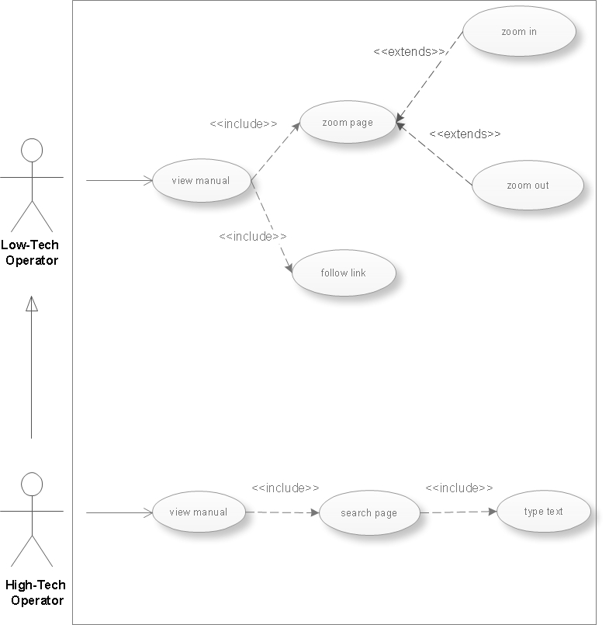

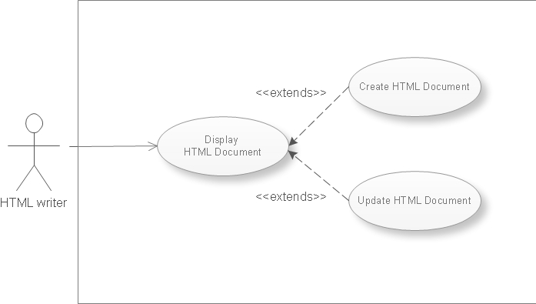

Basic and Alternatives course of events:

- View manual: Basic course of events:
  - User clicks open to open a file
  - System displays a browsing area for the user to choose among files.
  - User browses the files directories to find the one he wants to open
  - The system displays the HTML page successfully.
  - The user views the manual

1. View manual: Alternative course of events:
  - User clicks open to open a file
  - System displays a browsing area for the user to choose among files.
  - User browses the files directories to find the one he wants to open
  - The system displays the HTML page with missing content because of wrong use of the tags or displays a pop up window because the directory does not exists.

- Zoom page: Basic course of events:
  - The user performs the “View manual” use case.
  - The user choose zoom in or zoom out as many times as he needs.
  - The system displays the zoomed in or out page.

2. Zoom page: Alternative course of events:
1. The user performs the “View manual” use case.
2. The user choose zoom in or zoom out as many times as he needs.
3. The system displays the same page because zoom in or out has exceeded its limits.

- Search page: Basic course of events:
  - The user performs the “View manual” use case.
  - The user types a text to be searched in the page.
  - The system displays the searched text in the page by highlighting all of the occurrences of the searched text.

3. Search page: Alternative course of events:
  - The user performs the “View manual” use case.
2. The user types a text to be searched in the page.
3. The system displays a pop up window telling the user that the text have not been found

- Follow link: Basic course of events:
  - The user performs the “View manual” use case.
  - The user presses on a link.
  - The system displays the linked page.

4. Follow link: Alternative course of events:
  - The user performs the “View manual” use case.
  - The user presses on a link.
  - The system is not able to find the page and displays an error informing the user.

CRC cards

GUI
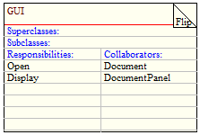

Parser
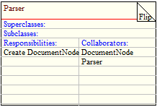

Document
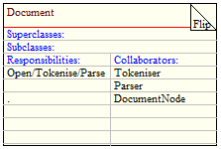

DocumentPanel
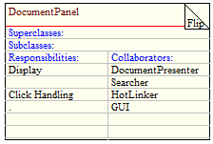

Tokeniser
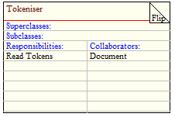

HotLinker
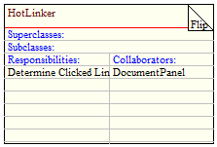

Searcher
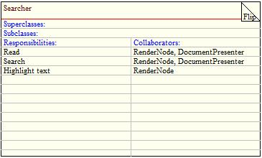

DocumentPresenter
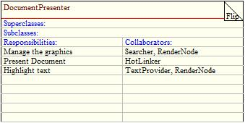

DocumentNode

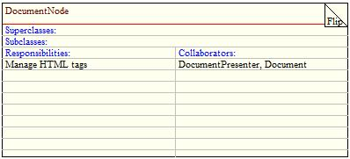

TextProvider
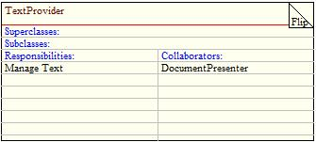

RenderNode
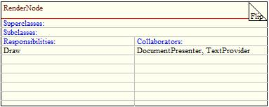

Collaborating classes identification

View manual

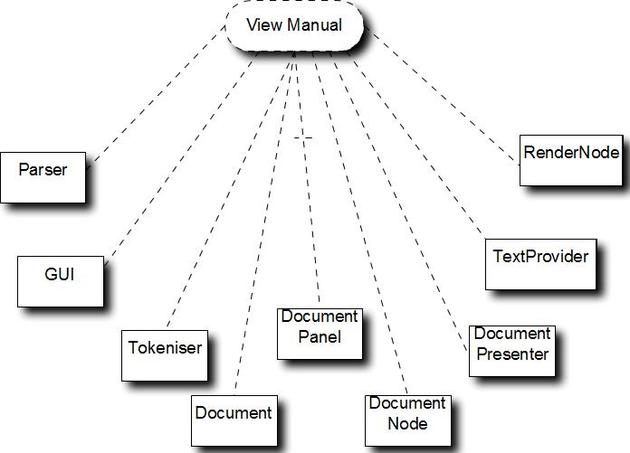

Follow link

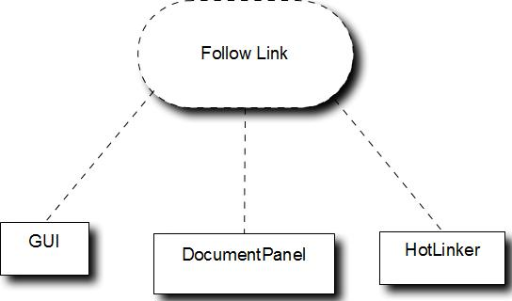

Search page

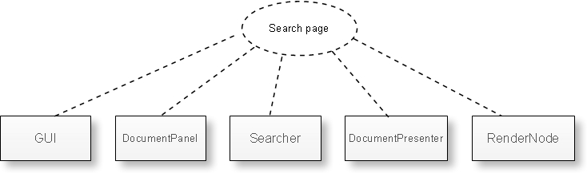

Zoom page

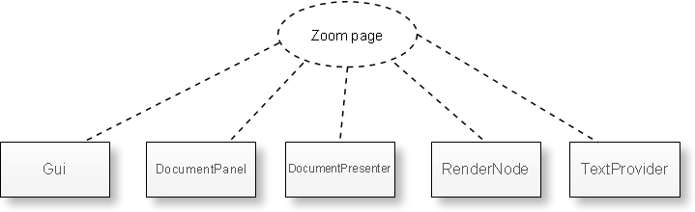

Initial class model

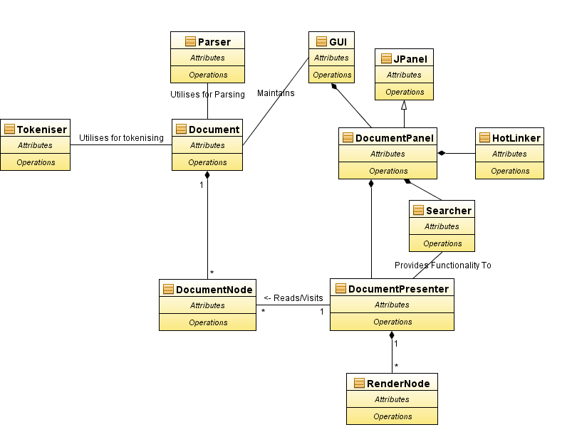

Appendix A – HTML 4.01 Transitional Elements

Opening Tag | Closing Tag | Description
<a> | </a> | Anchor
<abbr> | </abbr> | Abbreviated form
<acronym> | </acronym> | Acronym
<address> | </address> | Information on author
<applet> | </applet> | Java applet
<area> | none | Client-side image map area
<b> | </b> | Bold text
<base> | none | Document base uri
<basefont> | none | Base font size
<bdo> | </bdo> | I18n bidi over-ride
<big> | </big> | Large text
<blockquote> | </blockquote> | Long quotation
<body> | </body> | Document body
<br> | none | Forced line break
<button> | </button> | Push button
<caption> | </caption> | Table caption
<center> | </center> | Center
<cite> | </cite> | Citation
<code> | </code> | Computer code fragment
<col> | none | Table column
<colgroup> | </colgroup> | Table column group
<dd> | </dd> | Definition description
<del> | </del> | Deleted text
<dfn> | </dfn> | Instance definition
<dir> | </dir> | Directory list
<div> | </div> | Generic language/style container
<dl> | </dl> | Definition list
<dt> | </dt> | Definition term
<em> | </em> | Emphasis
<fieldset> | </fieldset> | Form control group
<font> | </font> | Local change to font
<form> | </form> | Interactive form
<frame> | none | Subwindow
<frameset> | </frameset> | Window subdivision
<h1> | </h1> | Heading
<h2> | </h2> | Heading
<h3> | </h3> | Heading
<h4> | </h4> | Heading
<h5> | </h5> | Heading
<h6> | </h6> | Heading
Conforming Non-rendered HTML Tags continued

Opening Tag | Closing Tag | Description
<head> | </head> | Document head
<hr> | none | Horizontal rule
<html> | </html> | Document root element
<i> | </i> | Italic text style
<iframe> | </iframe> | Inline subwindow
<img> | </img> | Embedded image
<input> | </input> | Form control
<ins> | </ins> | Inserted text
<isindex> | </isindex> | Single line prompt
<kbd> | </kbd> | Text to be entered by user
<label> | </label> | Form field label text
<legend> | </legend> | Fieldset legend
<li> | </li> | List item
<link> | </link> | A media-independent link
<map> | </map> | Client-side image map
<menu> | </menu> | Menu list
<meta> | </meta> | Generic metainformation
<noframes> | </noframes> | Alternate content container for non frame-based rendering
<noscript> | </noscript> | Alternate content container for non script-based rendering
<object> | </object> | Generic embedded object
<ol> | </ol> | Ordered list
<optgroup> | </optgroup> | Option group
<option> | </option> | Selectable choice
<p> | </p> | Paragraph
<param> | </param> | Named property value
<pre> | </pre> | Preformatted text
<q> | </q> | Short inline quotation
<s> | </s> | Strike-through text style
<samp> | </samp> | Sample program output, scripts, etc.
<script> | </script> | Script statements
<select> | </select> | Option selector
<small> | </small> | Small text
<span> | </span> | Generic language/style container
<strike> | </strike> | Strike-through text
<strong> | </strong> | Strong emphasis
<style> | </style> | Style info
<sub> | </sub> | Subscript
Conforming Non-rendered HTML Tags continued

Opening Tag | Closing Tag | Description
<sup> | </sup> | Superscript
<table> | </table> | Table
<tbody> | </tbody> | Table body
<td> | </td> | Table data cell
<textarea> | </textarea> | Multi-line text field
<tfoot> | </tfoot> | Table footer
<th> | </th> | Table header cell
<thead> | </thead> | Table header
<title> | </title> | Document title
<tr> | </tr> | Table row
<tt> | </tt> | Teletype text style
<u> | </u> | Underlined text style
<ul> | </ul> | Unordered list
<var> | </var> | Variable or program argument

The comment tag <!-- and --> and any enclosed text or elements will be ignored.

Appendix B – ASCII Characters

Whitespace characters

ASCII Value | Character | ASCII Value | Character
0 | NUL null | 16 | DLE data link escape
1 | SOH start of heading | 17 | DC1 device control 1
2 | STX start of text | 18 | DC2 device control 2
3 | ETX end of text | 19 | DC3 device control 3
4 | EOT end of transmission | 20 | DC4 device control 4
5 | ENQ enquiry | 21 | NAK negative acknowledge
6 | ACK acknowledge | 22 | SYN synchronous idle
7 | BEL bell | 23 | ETB end of trans block
8 | BS backspace | 24 | CAN cancel
9 | TAB horizontal tab | 25 | EM end of medium
10 | LF NL line feed/new line | 26 | SUB substitute
11 | VT vertical tab | 27 | ESC escape
12 | FF NP form feed/new page | 28 | FS file separator
13 | CR carriage return | 29 | GS group separator
14 | SO shift out | 30 | RS record separator
15 | SI shift in | 31 | US unit separator

Non-whitespace characters

ASCII Value | Character | ASCII Value | Character | ASCII Value | Character
32 | space | 64 | @ | 96 | `
33 | ! | 65 | A | 97 | a
34 | " | 66 | B | 98 | b
35 | # | 67 | C | 99 | c
36 | $ | 68 | D | 100 | d
37 | % | 69 | E | 101 | e
38 | & | 70 | F | 102 | f
39 | ' | 71 | G | 103 | g
40 | ( | 72 | H | 104 | h
41 | ) | 73 | I | 105 | i
42 | * | 74 | J | 106 | j
43 | + | 75 | K | 107 | k
44 | , | 76 | L | 108 | l
45 | - | 77 | M | 109 | m
46 | . | 78 | N | 110 | n
47 | / | 79 | O | 111 | o
48 | 0 | 80 | P | 112 | p
49 | 1 | 81 | Q | 113 | q
50 | 2 | 82 | R | 114 | r
51 | 3 | 83 | S | 115 | s
52 | 4 | 84 | T | 116 | t
53 | 5 | 85 | U | 117 | u
54 | 6 | 86 | V | 118 | v
55 | 7 | 87 | W | 119 | w
56 | 8 | 88 | X | 120 | x
57 | 9 | 89 | Y | 121 | y
58 | : | 90 | Z | 122 | z
59 | ; | 91 | [ | 123 | {
60 | < | 92 | \ | 124 | |
61 | = | 93 | ] | 125 | }
62 | > | 94 | ^ | 126 | ~
63 | ? | 95 | _

Appendix C – Supported HTML Standard Character Entities

ISO 8859-1 Symbols
Reference | Entity | Decimal | Hexadecimal | Description
&nbsp; |  | &#160; | &#xA0 | non-breaking space
&pound; | £ | &#163; | &#xA3 | pound
&copy; | © | &#169; | &#xA9 | copyright
&reg; | ® | &#174; | &#xAE | registered trademark

ISO 8859-1 Characters
Reference |  | Entity | Decimal | Hexadecimal | Description
&trade; | ™ |  | &#8482; | &#x2122; | trademark

Reserved Characters
Reference | Entity | Decimal | Hexadecimal | Description
&quot; | " | &#34; | &#x22; | quotation mark
&apos; | ' | &#39; | &#x27; | apostrophe
&amp; | & | &#38; | &#x26; | ampersand
&lt; | < | &#60; | &#x3C; | less-than
&gt; | > | &#62; | &#x3E; | greater-than

Appendix D – Supported Font Colour Names

BrowserMonkey supports the 16 valid colour names from the Windows VGA palette,as specified by the Worldwide Web Consortium HTML and CSS standards. Other colours must be accessed by using the hexadecimal #RRGGBB format which is not case sensitive.

Colour Name | #RRGGBB
Black | #000000
Silver | #C0C0C0
Gray | #808080
White | #FFFFFF
Maroon | #800000
Red | #FF0000
Purple | #800080
Fuchsia | #FF00FF
Green | #008000
Lime | #00FF00
Olive | #808000
Yellow | #FFFF00
Navy | #000080
Blue | #0000FF
Teal | #008080
Aqua | #00FFFF

Appendix E – GUI Prototype

Appendix F – References

1 Customer Requirements document version 6.6 supplied as part of the Project description on Study Direct.

2 Worldwide Web Consortium Notes on invalid documents. [online] Available from: http://www.w3.org/TR/REC-html40/appendix/notes.html#notes-invalid-docs [Accessed 28 February 2009]

Appendix G – List of Abbreviations

ASCII American Standard Code for Information Interchange
CSS Cascading Style Sheets
DTD Document Type Definition
GUI Graphical User Interface
HTML Hypertext Markup Language
SGML Standard Generalized Markup Language
UML Unified Modelling Language
URL Uniform Resource Locator
VGA Video Graphics Array

